Name:________________________________ Hour:____________ Date:______________________
Q-Tip Skeletons
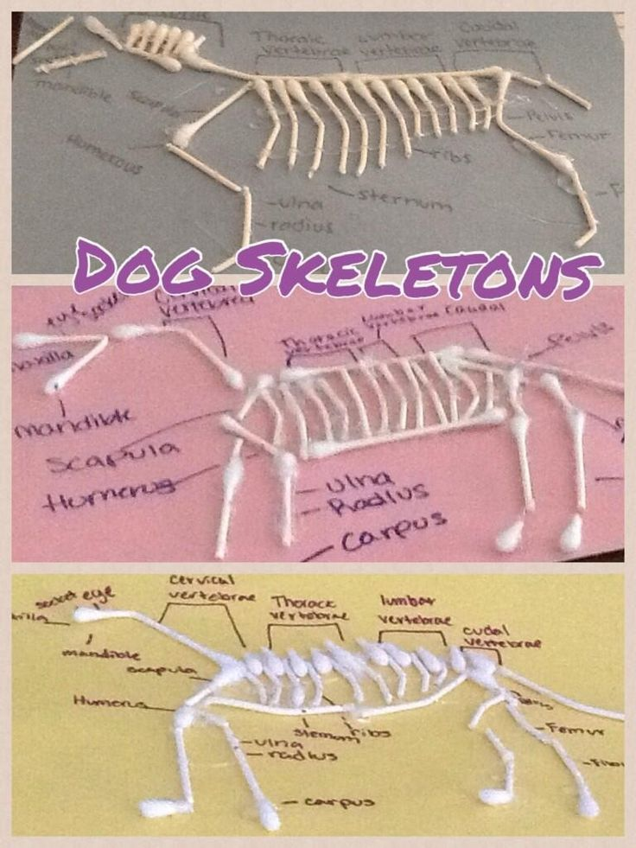
Supplies:
- Q-Tips
- Marker/Pen of labels
- Diagram of Animal Skeleton
- Glue

Directions:
- Choose an animal & find a diagram of its skeleton
- Make a model of the skeleton using Q-Tips & Glue
- Label a minimum of 20 bones:
- Follow the rubric below for additional requirements

Category | Points Possible | Points Earned
Overall Correctness (It Looks like an Animal) | 5
20 Bones Labeled | 20
Correct Name & Location of Bones | 10
Neat & Creative | 5
TOTAL | 40 Points

