Name___________________________________ Period_________ Date_______________________

Suture Lab Sheet

Materials Needed
- Patient (foam)
- Suture needle
- Suture Material (dental floss)
- Needle holders

Instructions
- Gather materials
- Complete suture stitches/patterns for each stitch shown below
- When finished turn in Patient with lab sheet.

Continuous Stitch: Interrupted Stitch:
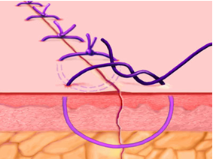
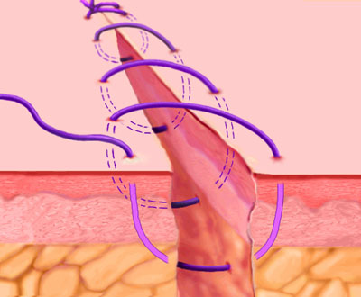

Name___________________________________ Period_________ Date_______________________

Suture Lab Sheet

Materials Needed
- Patient (foam)
- Suture needle
- Suture Material (dental floss)
- Needle holders

Instructions
- Gather materials
- Complete suture stitches/patterns for each stitch shown below
- When finished turn in Patient with lab sheet.

Continuous Stitch: Interrupted Stitch:

GRADING RUBRIC
Continuous Stitch | Points Possible | Points Earned
Uniform evenly-spaced, neat stitches | 5
Knots at both ends | 2
10 Sutures total | 10
Interrupted Stitch | Points Possible | Points Earned
Uniform evenly-spaced, neat stitches | 5
Knots at each suture | 10
10 Sutures total | 10
TOTAL | 42

GRADING RUBRIC
Continuous Stitch | Points Possible | Points Earned
Uniform evenly-spaced, neat stitches | 5
Knots at both ends | 2
10 Sutures total | 10
Interrupted Stitch | Points Possible | Points Earned
Uniform evenly-spaced, neat stitches | 5
Knots at each suture | 10
10 Sutures total | 10
TOTAL | 42

