Name:________________________________ Hour:___________ Date:______________________
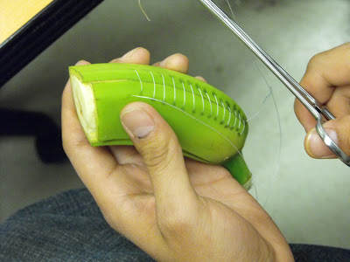
Banana Suturing Lab

Materials Needed
- Patient (banana)
- Suture needle
- Suture Material (dental floss)
- Needle holders
- Plastic Knife

Directions
- Cut banana in half.
- Peel back banana 2”-3” so there’s 2 sections (don’t peel completely)
- Thread dental floss into needle
- Sew one side using a Continuous method.
- Sew the other side using Interrupted method.
- On the cut end put a purse-string suture.
- When finished have banana sutures grade by teacher based on the rubric below.

Name:________________________________ Hour:___________ Date:______________________
Banana Suturing Lab

Materials Needed
- Patient (banana)
- Suture needle
- Suture Material (dental floss)
- Needle holders
- Plastic Knife

Directions
- Cut banana in half.
- Peel back banana 2”-3” so there’s 2 sections (don’t peel completely)
- Thread dental floss into needle
- Sew one side using a Continuous method.
- Sew the other side using Interrupted method.
- On the cut end put a purse-string suture.
- When finished have banana sutures grade by teacher based on the rubric below.

GRADING RUBRIC
Continuous Suture | Points Possible | Points Earned
Uniform evenly-spaced, neat stitches | 10
Knots at both ends | 5
Interrupted Suture | Points Possible | Points Earned
Uniform evenly-spaced, neat stitches | 10
Knots at each suture | 10
Pure-String Suture | Points Possible | Points Earned
Loops every ½” | 10
Double floss strung through the loops & tightened | 5
TOTAL | 50

GRADING RUBRIC
Continuous Suture | Points Possible | Points Earned
Uniform evenly-spaced, neat stitches | 10
Knots at both ends | 5
Interrupted Suture | Points Possible | Points Earned
Uniform evenly-spaced, neat stitches | 10
Knots at each suture | 10
Pure-String Suture | Points Possible | Points Earned
Loops every ½” | 10
Double floss strung through the loops & tightened | 5
TOTAL | 50

