Name_________________________________________ Hour_________________ Date_________________________

Plant Anatomy Review

Directions: Match terms associated with plant growth and development to the correct definitions.

- _____ Union of the male (pollen) nucleus with the female
(egg) cell
- Bud
- Dicot
- Embryo
- Epicotyl
- Fertilization
- Hypocotyl
- Internode
- Leaf scar
- Monocot
- Node
- Ovary
- Phloem
- Pistil 12. Stamen
- Pollination
- Radicle
- Stamen
- Vascular bundle scar
- Xylem

- _____ Plant having two seed leaves

- _____ The part of a stem between two nodes

- _____ Vascular tissue that transports water and minerals
from the root system to the leaves

- _____ Seed bearing organ of a flower; composed of ovary,
style and stigma

- _____ Plant having one seed leaf

- _____ The part of a stem where a leaf is attached

- _____ Transfer of pollen from the anther to the stigma

- _____ Part of the flower which produces the pollen;
composed of the filament and anther

- _____ The flower structure where seeds develop

- _____ Vascular tissue that conducts food from the
leaves to regions of growth or storage

Seeds
- Select from the following list factors that cause poor seed germination. Write an "X" in the blank before each correct answer.

_____a. Number of seeds per pound

_____b. Seeds planted too deeply in soil

_____c. Presence of hardpan in root zone

_____d. Fungal disease

_____e. Low soil temperature

_____f. Low soil moisture

_____g. Damaged seed

_____h. Deficiency of nutrients in soil

_____i. Period of time between harvesting and planting of seed

_____j. Conditions under which seed is stored

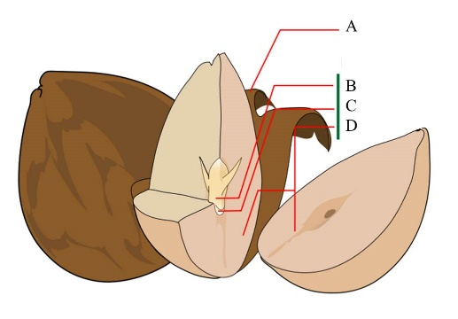
13. Label the anatomy of a seed

Roots

14. Name two types of root systems.

15. List the purpose of each part of the root

- Apical meristem _________________________________
- Root Cap _________________________________
- Epidermis _________________________________
- Root Hairs _________________________________
- Xylem _________________________________
- Phloem _________________________________
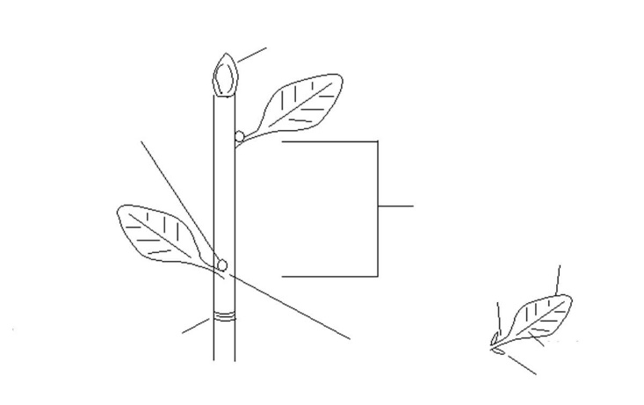
Stems
- What is the purpose of a stem?

- List 4 types of modified stems

- Label the stem picture to the right.

Leaves
- What are the functions of leaves?

- List 3 types of leaf attachment

Flowers
- What is the difference between a complete flower and incomplete flower?

- What is the difference between a perfect flower and imperfect flower?

- Be prepared to label the parts of a flower!

Fruits
- What is the scientific definition of a fruit?
- The skin of the fruit is considered the ___________________.
- Give 3 examples of a fleshy pericarp
- Give 3 examples of a dry pericarp
- Give 3 examples of aggregate fruits
- What is the difference between a drupe and a pome?

