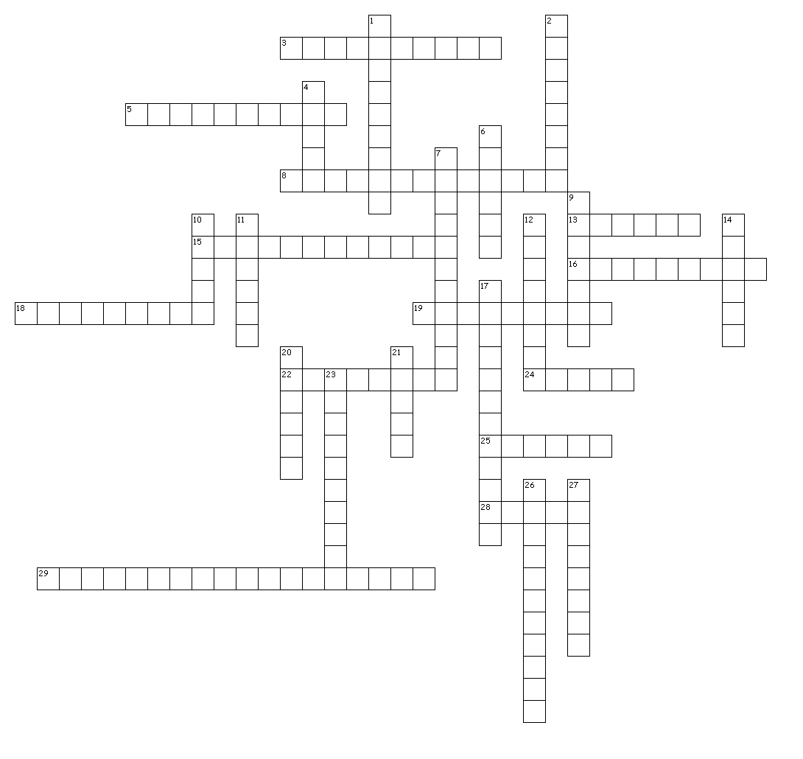
Equine Reproduction & Parturition Crossword

Across
3. The term for when the fetus is made during fertilization.
5. Term for multiple cycles throughout specific times of year.
8. Where fertilization occurs in the female reproductive tract.
13. This divides the vagina and the uterus.
15. The time between periods of "heat" or estrous.
16. Release of eggs from the mare.
18. The 2nd part of the Estrous Cycle when ovulation occurs, LH is produced.
19. The 4th part of the Estrous Cycle when the body prepares to begin the cycle again.
22. The term for the non-ovulating period.
24. Produced by the Prostate and Vesicular Glands.
25. Semen that changes temperature from 100 to 41 degrees and remains viable for 24-72 hours.
28. Produces eggs and hormones.
29. The measure of subcutaneous fat on a scale of 1 to 9.
Down
1. The term for length of pregnancy, 11 months in Equines.
2. Produces sperm & testosterone.
4. The opening of the female reproductive tract.
6. The 1st part of the estrous cycle, when the mare is receptible to the stallion and conception can occur.
7. Transport semen to the Epididymis.
9. Protects the testicles and maintain temperature.
10. Places sperm into the female reproductive tract.
11. Where the fetus develops and receives nourishment.
12. The 3rd part of the Estrous Cycle when the system assumes pregnancy & produces progesterone.
14. Semen is collector and extender is added to it, can be stored indefinitely but there is a 35% pregnancy rate.
17. The process of creating offspring.
20. The birth canal and area of conception.

21. Semen that is stored at 55 degrees & must be used with 24 hours of collection.
23. Collects and stores sperm.
26. The term for the act of giving birth.
27. The term for difficulty giving birth.

