Name: __________________________________ Hour: _________ Date: ___________________
Animal Reproduction Test Review
Terms to Know:

- Dystocia
- Egg
- Estrous Cycle
- Estrus
- Fertilization
- Gestation
- Ovaries
- Ovulation
- Pregnancy
- Semen
- Sperm
- Testes

Gestation Lengths for:
-Cow -Horse -Pig
-Sheep & Goats -Chickens
Describe and give one advantage of the following reproductive technologies:
-Artificial Insemination:
-Estrus Synchronization:

Name: __________________________________ Hour: _________ Date: ___________________
Animal Reproduction Test Review
Terms to Know:

- Dystocia
- Egg
- Estrous Cycle
- Estrus
- Fertilization
- Gestation
- Ovaries
- Ovulation
- Pregnancy
- Semen
- Sperm
- Testes

Gestation Lengths for:
-Cow -Horse -Pig
-Sheep & Goats -Chickens
Describe and give one advantage of the following reproductive technologies:
-Artificial Insemination:
-Estrus Synchronization:
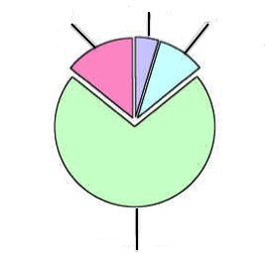
-Embryo Transfer:
-Cloning:
Describe the 4 parts of the Estrous Cycle
1-
2-
3-
4-
Be able to identify a normal birth presentation.

Why is it important for animal producers to understand principles of animal breeding?

What are signs that animal will soon give birth?

List the 4 stages of Parturition:

1- 2-

3- 4-

-Embryo Transfer:
-Cloning:
Describe the 4 parts of the Estrous Cycle
1-
2-
3-
4-
Be able to identify a normal birth presentation.

Why is it important for animal producers to understand principles of animal breeding?

What are signs that animal will soon give birth?

List the 4 stages of Parturition:

1- 2-

3- 4-

